Below is the copy of the Op-ed by Nicholas Kristof in the NY Times yesterday, September 2nd, 2020.

Here below are the links to the English and the Somali versions of the FGM Booklets:
https://drive.google.com/file/d/1Iofpu-vTjclsDHVBHasdBdYim7ZWQS5q/view?usp=sharing

https://drive.google.com/file/d/1eoHx5SHPTLLLWwrFXeFCRjYflM9ODGQl/view?usp=drive_web

Thank you for sharing as widely as possible. Let us save as many little girls from this terrible ordeal.
Edna Adan Ismail

Website : www.ednahopsital.org
e-mail: ednahospital@yahoo.com

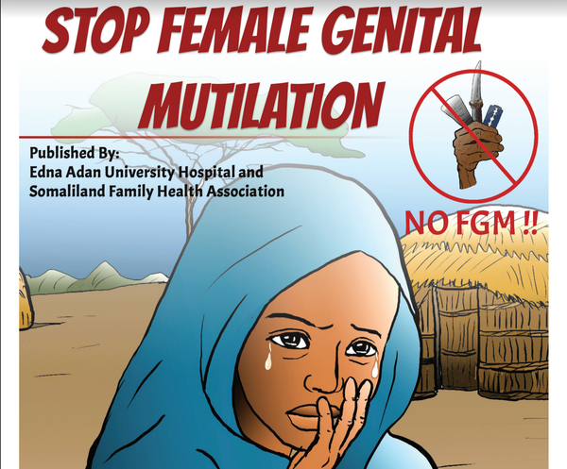

The winner of my “Holiday Impact Prize” late last year was Edna Adan, who runs a university hospital in Somaliland. Readers raised hundreds of thousands of dollars for her fight against maternal mortality, cervical cancer and female genital mutilation (F.G.M.) — for which I’m so grateful. Now Edna and her hospital have published a new booklet (pictured above) to discourage F.G.M., which affects 99 percent of girls in Somaliland.
The booklet uses medical and religious authority to argue that F.G.M. is harmful; it quotes doctors as warning against it and an imam noting that the Prophet Muhammad never “circumcised” his daughters. The booklet is principally in Somali, but here’s an English version and it’s also being translated into Arabic. Edna says that she welcomes others translating it into local languages.

Westerners often criticize F.G.M., but it’s so much more effective when the fight is led by a Somali Muslim like Edna. So thanks, Edna, for all you do — and thanks, readers, for supporting her. You can find out more about her work here.

